Contact: Natalie Jacobsen
media@cfcnca.org
434-228-8789

Federal employees in the National Capital Area raise over $2 million for charity on #GivingTuesday; virtually volunteered with charities for International Volunteer Day

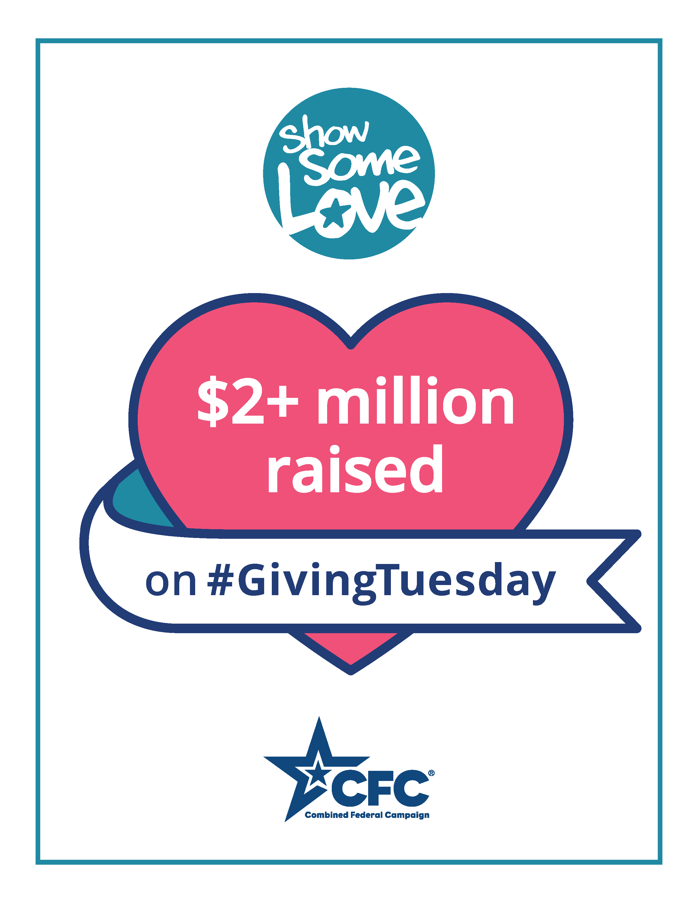WASHINGTON, Dec. 9, 2020 – Federal employees and retirees donated over $2 million through the Combined Federal Campaign of the National Capital Area (CFCNCA) last week on Giving Tuesday (Dec. 1). This marks the most successful Giving Tuesday for the CFCNCA. By the end of the week, the CFCNCA raised almost $4 million for supported charities, the biggest week of the 2020 campaign to date.

“The results of Giving Tuesday and overall in the campaign so far has exceeded our expectations,” said Vince Micone, Co-Chairperson of the CFCNCA. “It has blown us away how eager federal employees and retirees have been to Show Some Love this year. Though we’ve been treading new waters and operating entirely virtual, it’s been thrilling to see such a positive response by the federal community.”

To date, generous federal employees, including military, civilians, postal workers and retirees have pledged over $17.3 million to thousands of charities supported by the campaign, putting the CFCNCA over halfway to its 2020 goal of “meet or beat $30 million.”

“Our collective giving has accelerated,” said Micone. “Our Giving Tuesday results were 38% higher than those of 2019; we are currently trending 15% ahead of overall fundraising compared to recent years – and we hope and believe – we will keep this momentum going right through January 15th, the closing date of the 2020 campaign.” CFCNCA donors contributed to the over $2.47 billion given in the United States alone to charities on Giving Tuesday, which experienced an overall 25% increase since 2019 itself!

Ann Van Houten, Co-Chairperson, said, “Coming together, wherever we are, through our annual federal workplace giving campaign has been essential to thousands of charities in the CFC – and a testament to the selfless dedication of our federal, military and postal community. I could not be more proud to be part of such a generous community.”

To recognize International Volunteer Day on December 5th, CFCNCA staff, board members and campaign workers participated in four virtual volunteer opportunities at CFC charities, including Mercy Corps, HUGS, and Seabury Resources for Aging. Volunteers wrote thank-you letters to workers on the front lines of the pandemic, put together care packages for deployed military members, created art for refugee children, and held conversation, music, and trivia classes for senior residents. Federal employees, postal and military workers who pledged volunteer hours in the 2019 campaign interested in volunteering should reach out to the charity they pledged to find out what opportunities, including virtual, are available to take part in this holiday season.

A video documenting a reflection on the opportunities and efforts is available here for viewing.

“Through the CFC, we have become everyday philanthropists, and shown that we can all Be the Face of Change this year: a year that has been so difficult for so many who are in need of hope and help,” said Van Houten.

The 2020 CFC runs through January 15, 2021. Federal employees and retirees who are interested in learning more and pledging can do so at GiveCFC.org.

About the Combined Federal Campaign of the National Capital Area
For the past 59 years, the Combined Federal Campaign (CFC) has been the federal workplace giving tradition that has raised more than $8.4 billion for charitable organizations. The CFC is one of the world’s most successful annual workplace fundraising campaigns, with 36 CFC zones throughout the country and overseas raising millions of dollars each year. The funds raised each fall through the campaign help neighbors in need around the corner, across the nation, and throughout the world. The Combined Federal Campaign of the National Capital Area (CFCNCA) is the local campaign for federal employees and retirees in the Washington Metropolitan Area and surrounding regions. It is the largest CFC in the country based on the number of pledged gifts. Through the contributions of civilian and military federal employees and retirees, the campaign generated more than $34.2 million and more than 69,500 volunteer hours in 2019 for thousands of participating local, national, and international charities. For more information, visit GiveCFC.org. Connect with the campaign on social media via Facebook, Twitter, Instagram, and LinkedIn.

# # #

