Contact: Natalie Jacobsen
Mobile - 434.228.8789
media@cfcnca.org

CFCNCA Starts Final Push of 2021 Campaign
Federal employees and retirees can pledge through January 15

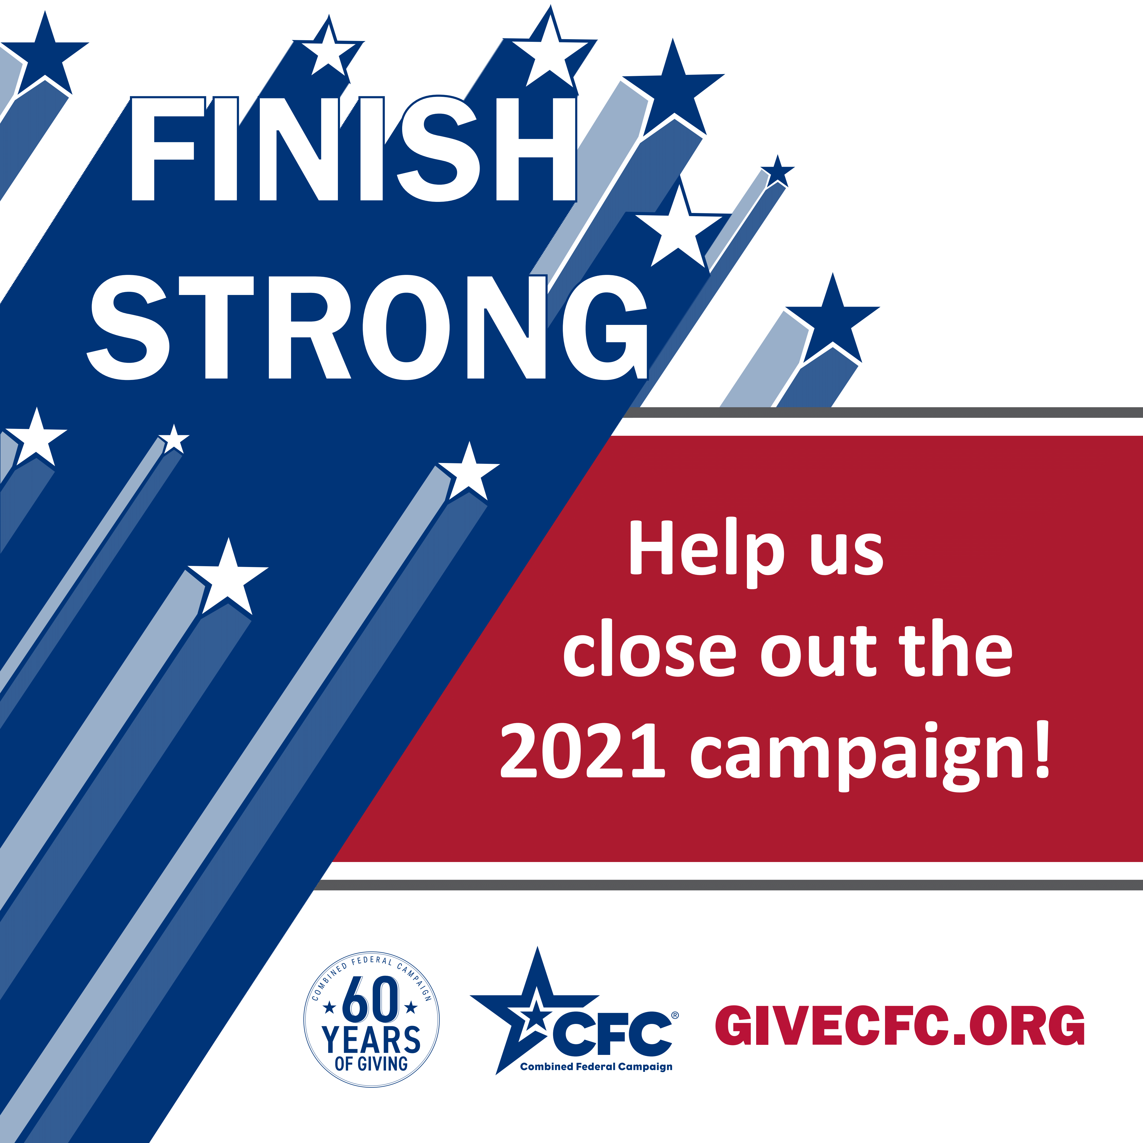
WASHINGTON, Jan. 10, 2022 – The Combined Federal Campaign of the National Capital Area (CFCNCA) is making a final push for contributions during the last week of the campaign. The annual charitable giving program for federal employees and retirees in the Washington metropolitan area and surrounding regions concludes on Jan. 15, 2022.

“We have had an outstanding year for the campaign. We broke records around Giving Tuesday, saw tens of thousands of supporters join our Kickoff and events, and demonstrated our steadfast dedication to improving lives of others with our pledges. Our local, national, and international neighbors will see the impact of these gifts this year and beyond,” said Vince Micone, Co-Chairperson of the CFCNCA. “It’s been incredible to see how many changemakers are ready to step up and lend a hand through a generous pledge and volunteer time.”

To countdown the final days of the campaign, leaders are walking through the six decades of the campaign with engagement activities and sharing of memories since President Kennedy signed the Executive Order that created the program in 1961. In the 1970s, payroll deduction was introduced as a form of charitable contribution. It is still the most prominent way federal employees pledge through the CFC. The Office of Personnel Management established local leadership roles for the CFC in the 1980s. During the 1990s, as many as 53% of the entire federal workforce made a pledge through the CFC. In the last decade, volunteerism and a consolidated giving portal were introduced. Today the CFC is recognized as one of the most inclusive, successful workplace giving campaign in the world.

Federal employees and retirees are invited to consider honoring sixty years of CFC impact with their own pledge of $60 or take part in a 60-minute volunteer activity through the Do 60, Give 60 movement.

Ann Van Houten, Co-Chairperson, said, “We only have a few days left to make a difference in this year’s campaign and support our community. The federal workforce and retirees have always inspired us when they go above and beyond the call of duty to support their fellow Americans through hardship, and work to make the world a better place. We thank all who have pledged to-date for being changemakers.”

The goal for the 2021 CFCNCA is $35 million. To-date, over 91% of the goal, at just over $32 million, has been raised and counting!

Federal donors in the NCA can be the face of change and make a new or update an existing pledge at GiveCFC.org now through Jan. 15, 2022.

About the Combined Federal Campaign of the National Capital Area
The Combined Federal Campaign (CFC), overseen by the Office of Personnel Management, is one of the world's largest and most successful annual workplace charitable giving campaigns, with 36 CFC zones throughout the country and overseas raising millions of dollars each year. With more than $8.5 billion raised since 1961, the 2021 campaign commemorates 60 years of giving by the federal community. Each fall, federal civilian, military, and postal employees and retirees pledge funds and volunteer hours to help those in need locally, across the nation, and throughout the world. The Combined Federal Campaign of the National Capital Area (CFCNCA) is the local campaign for federal employees and retirees in the Washington Metropolitan Area and surrounding regions. It is the largest CFC in the country based on the number of pledged gifts; in 2020, it generated more than $37.2 million and more than 48,000 volunteer hours for thousands of participating charities. For more information, visit CFCNCA.GiveCFC.org. Connect with the campaign via Facebook, Twitter, Instagram, and LinkedIn.

# # #

