FROM: Campaign workers
TO: All staff
CONTENT: Do 60, Give 60 CFCNCA effort
DATE TO SEND: Early November
SUBJECT: I challenge you to Do 60, Give 60, with the CFCNCA!
ATTACHMENT: Do 60, Give 60 Flyer

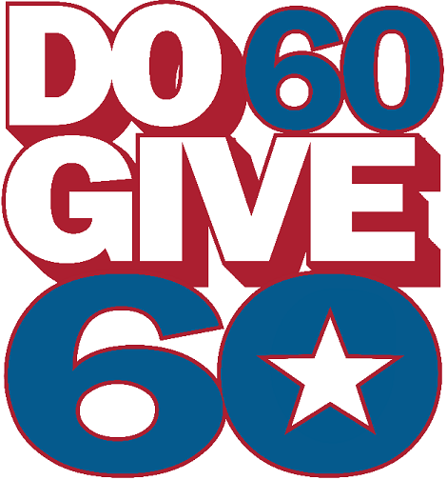

Dear Changemakers:

To recognize the 60th anniversary of the Combined Federal Campaign (CFC), we here in the CFCNCA are launching a new challenge, and are inviting all changemakers to take part!

Called the “Do 60, Give 60” activity, federal employees and retirees can celebrate 60 years of meaningful impact by volunteering for 60 minutes, and pledging a one-time $60 gift. You can learn more about the concept and how to participate here.

At [DEPARTMENT/AGENCY/OFFICE NAME], we will be hosting a “Do 60, Give 60” event and to have some CFC fun! On [DATE/DAY] at [TIME], join by [LINK/PLACE], and get ready to [INSERT ACTIVITY HERE]. We can’t wait to see you there!

In the meantime, you can brainstorm some ways to “Do 60” and get your whole family involved – here are some ideas!

- Volunteer at a local food pantry, animal shelter, soup kitchen, or park for 60 minutes.
- Take part in a physical challenge: walk for 60 minutes, do 60 push-ups, write 60 thank-you letters to frontline workers, dance for 60 seconds, or bike 60 miles.
- Finally, make a $60 pledge to honor your efforts through the online portal.
Through the CFC, we are all changemakers. For 60 years, we have been supporting local, national, and international communities in need. This year, let’s celebrate this milestone as we look ahead to the next 60 years of possibility. There’s no telling how far we’ll go when we come together through the CFC.

Thank you for being the face of change for charitable causes important to all of us, whether you’ve been giving since the beginning of your service, or this is your first time participating. Now let’s go Do 60, and Give 60!

Cheers,
[Campaign worker]
[Title]

